**OUTPUT SCREENSHOT**

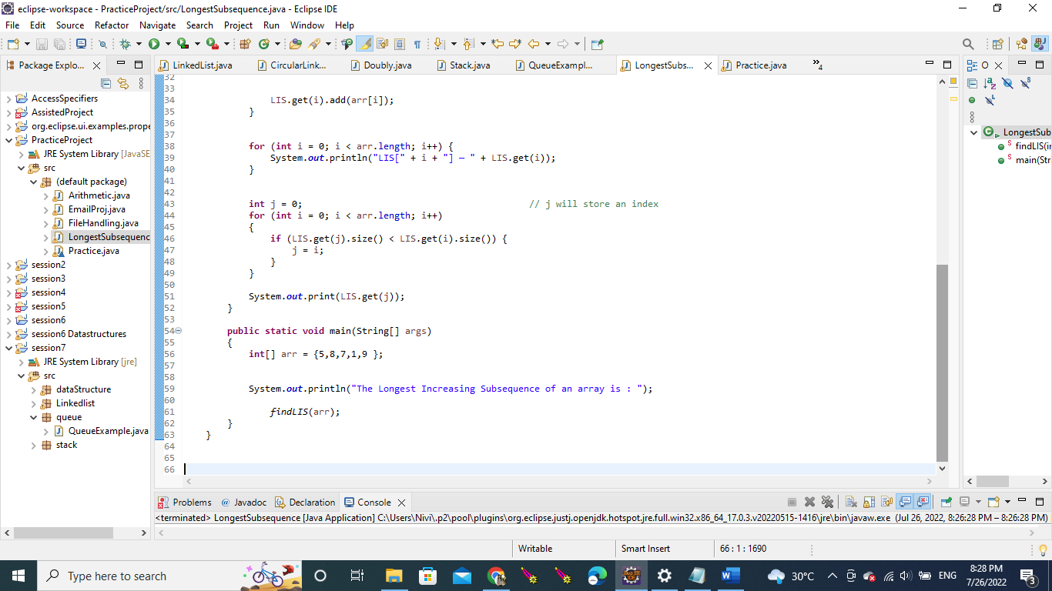

**SAMPLE OUTPUT:**

